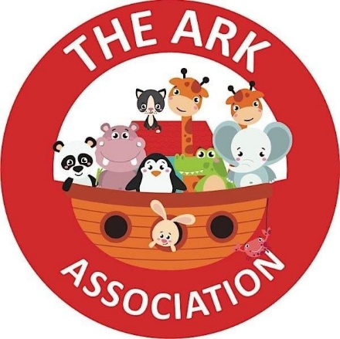

Parent’s Guide to the Early Years Foundation Stage Framework.
What is the Early years Foundation Stage?
The Early Years Foundation Stage is how the Government and Early years professionals (us) describe the time in your child’s life between birth to 5 years.
This is a very important stage as it helps develop and prepare your child for future learning and successes. From when your child is born up until the age of 5, their early experience should be happy, active, exciting, fun and secure. Early Years settings can help with this as well as supporting their development, care and learning needs.
All Nurseries and pre-schools registered to deliver the Early Years Foundation Stage must follow a legal document called the Early Years Foundation Stage Framework.

What is the EYFS framework and why do we have one?
The EYFS framework exists to support all professionals working in Early Years to help your child and was developed with a number of early years experts and parents.
The EYFS has recently been updated and this current document has been in effect since September 2021. ‘It sets the standards that all early years providers must meet to ensure the children learn and develop well and are kept healthy and safe. It promotes teaching and learning to ensure children’s school readiness and gives children the broad range of knowledge and skills that provide the right foundation for good future progress through school and life’ (Statutory framework for the early years foundation stage, 2021).
Alongside this it also sets out 4 guiding principles which should shape practice. These are:
- Every child is a unique child, who is constantly learning and can be resilient, capable, confident and self assured.
- Children learn to be strong and independent through positive relationships.
- Children learn and develop well in enabling environments with teaching and support from adults, who respond to their individual interests and needs and help them to build their learning over time. Children benefit from a strong partnership between practitioners and parents and/or carers.
- Importance of learning and development. Children develop and learn at different rates. This framework covers the education and care of all children in early years provision, including children with special educational needs and disabilities (SEND).

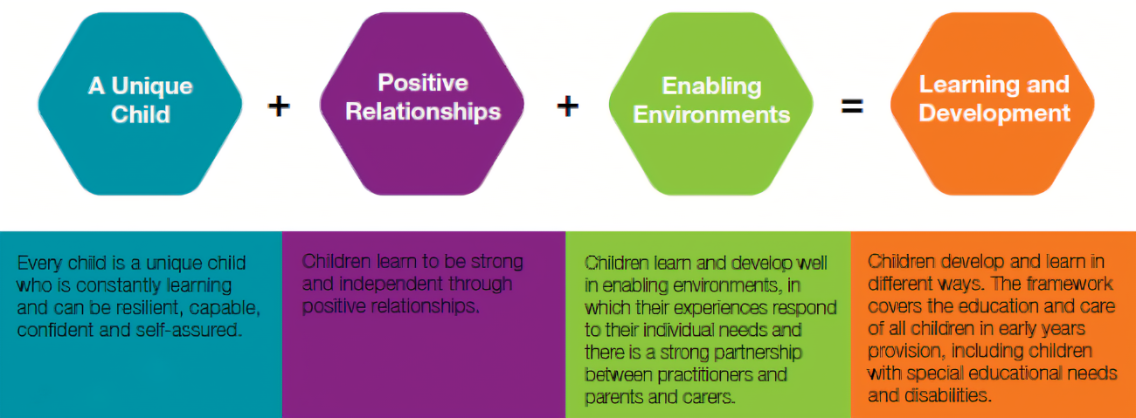

Also set out in the EYFS are the 7 areas of learning which guide professionals engagement with your child’s play. All areas of learning are interconnected; however they are set out in 2 categories. These are detailed below:
The following 3 areas are classed as prime areas and are particularly important for building a foundation for learning:
- Communication and language
- Physical development
- Personal, social and emotional development
Providers must also support a further 4 areas. These are classed as specific areas, through these the 3 prime areas are strengthened and applied:
- Literacy
- Mathematics
- Understanding the world
- Expressive arts and design
These 7 areas are used to plan your child’s learning and activities. The practitioners working with your child will ensure that children are making good progress in all 7 areas of learning and will tailor unique support to enable your child to achieve this. The activities designed are flexible and designed so that staff can follow children’s own unique interests and needs.
Children in the EYFS learn through playing, exploring and being active and creative both in and outdoors.

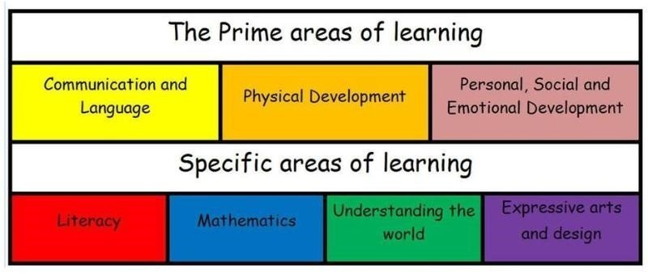

How can I find out how my child is getting on?
Parent partnership is really important to us and we actively encourage open communication with all of our parents and carers. We use Famly as our main communication tool with parents. By using Famly parents can see updates from Nursery, see what their child has been doing, keep up to date with upcoming events and see reminders from staff.
At The Ark your child’s key person will send you an end of term summary assessment at the end of each half term. This will be personalised to your child and will detail what the staff have been focusing on that term for your child. It will describe how they have been supported to gain new knowledge and skills and give you information on what will be focused on in the next term. Attached to this will be a section which tells you if your child is ‘progressing well’ and where they ‘need some support’ so you are able to see their progress in the areas of learning.

Progress check at the age of two years.
At some point between the ages of 2 and 3 years, your child’s key person must provide you with a summary of how your child is progressing against the 3 prime areas of learning:
- Communication and language
- Physical development and
- Personal, social and emotional development
This is called the progress check at age 2.
This check will highlight areas where your child is progressing well and any where they might need some extra support- and how you as patents or carers can work with the key person to help this. You may find it useful to share this information from the check with other professionals such as your Health Visitor.
At The Ark we do our 2 year checks at around 2 years and 10 months. These are shared with parents through Famly and we encourage parents to make any comments should they wish to.

Where can I get more information?
- The best place to get more information is from us! We can provide parents with more information regarding The Early Years Foundation Stage as well as ideas on what to expect from your child at certain ages and how you may be able to support this.
- There is a great document for parents if you follow the below link which you may find useful:
What-to-expect-in-the-EYFS-complete-FINAL-16.09-compressed.pdf (foundationyears.org.uk)
- The link to the full Early Years Foundation stage document is also below:
Statutory framework for the early years foundation stage (publishing.service.gov.uk)

